**1. (10 points) Given the token bucket size, b bytes; token rate, r bytes/sec; and maximum output rate M bytes/sec, what is the maximum burst time T?**

**Ans:** The token bucket is an algorithm used in packet-switched computer networks and telecommunication networks. It can be used to check that data transmissions, in the form of [packets](https://en.wikipedia.org/wiki/Network_packet), conform to defined limits on [bandwidth](https://en.wikipedia.org/wiki/Bandwidth_(computing)) and [burstiness](https://en.wikipedia.org/wiki/Burst_transmission) (a measure of the unevenness or variations in the [traffic](https://en.wikipedia.org/wiki/Network_traffic_measurement) flow). It can also be used as a [scheduling algorithm](https://en.wikipedia.org/wiki/Scheduling_algorithm) to determine the timing of transmissions that will comply with the limits set for the bandwidth and burstiness: see [network scheduler](https://en.wikipedia.org/wiki/Network_scheduler).

When a packet is to be checked for conformance to the limits, the bucket is inspected to see if it contains sufficient tokens at that time. If happens, then the number of tokens is removed and the packet is passed for transmission.

The basic steps to calculate the burst time are as follows:

1. A token is added to the bucket every 1/r seconds.

2. Bucket size (b bytes ) means the bucket can hold at the most b tokens and if a token arrives

when the bucket is full then that will be discarded.

3. If a packet of ‘n’ bytes arrives then ‘n’ tokens will be removed from the bucket and is sent to the

network. And if fewer than ‘n’ tokens are available, then no tokens will be removed from the

bucket.

4. Considering M is a maximum output rate and r is a token rate then maximum burst time(Tmax)

will be:

**Tmax = b / (M-r) if r < M**

**∞ otherwise**

5. In the above equation, Tmax is the time for which the rate M is fully utilized. Therefore, the

maximum burst time is **Tmax = b/(M-r)**.

(Reference: <https://en.wikipedia.org/wiki/Token_bucket>)

**2. (50 points) Study the AWS Direct Connect service and answer the following questions:**

**a. (business) You own a company with a data center in Sapporo, Japan. Which company would you choose to connect this location to the Amazon service? Can you find out about pricing and QoS guarantees? (This may require some research. If you are unable to find the exact answers, describe what you have done to find them and what remains to be done.)**

**b. (technical) As you have noticed, the AWS Direct Connect service description refers to the IEEE standard 802.1q. Read this standard (which you should be able to find at http://www.ismlab.usf.edu/dcom/Ch3_802.1Q-2005.pdf or at the Stevens Library) and explain how a dedicated connection can be partitioned into multiple virtual interfaces so as to allow you to “use the same connection to access public resources such as objects stored in Amazon S3 using public IP address space, and private resources such as Amazon EC2 instances running within an Amazon Virtual Private Cloud (VPC) using private IP space.”**

**Ans: AWS Direct Connect** makes it easy to establish a dedicated network connection from premises to AWS.

We can establish private connectivity between AWS and data center, office, co-location environment, which in many cases can reduce network costs, increase bandwidth throughput, and provide a more consistent network experience than Internet-based connections.

a. If I happen to own a company with a data center in Sapporo, Japan. I would choose to connect Equinix OS1, Osaka, Japan among other partners to connect this location to the AWS. As with Equinix data centers

• High-performance, private access to AWS Direct Connect options are offered.

• Based on the data volume, AWS Direct Connect customers can cut data transfer costs by two to

ten times.

• Offers Amazon Direct Connect Services covers more geographical locations than any other data

center provider.

• It provides a flexible range of seeds with virtual connections via the Equinix Cloud Exchange.

• Offers facility to migrate to hybrid cloud computing.

**QoS Guarantees:**

• Reliability - All Equinix IBX data centers are equipped with full UPS power, back up systems and N+1 redundancy with a proven industry-leading > 99.99999% uptime record.

• Security - Each Equinix IBX data center utilizes an array of security equipment, techniques and procedures to control, monitor, and record access to the facility, including individual cages.

• High average uptime—Our IBX data centers boast an industry-leading track record of >99.99999%.

• Proven expertise—We can help you configure and support your high-power density deployments.

• Recovery – IBXflexTM Space provides operations centers and storage space when you need it. Equinix Smart HandsTM offers 24-hour access to qualified technical support—with Equinix, you can maintain your mission-critical operations and equipment under any circumstances.

• Power Density – With robust heating, ventilation and air conditioning (HVAC) systems, Equinix IBX data centers exceed the requirements of even the most power-hungry deployments.

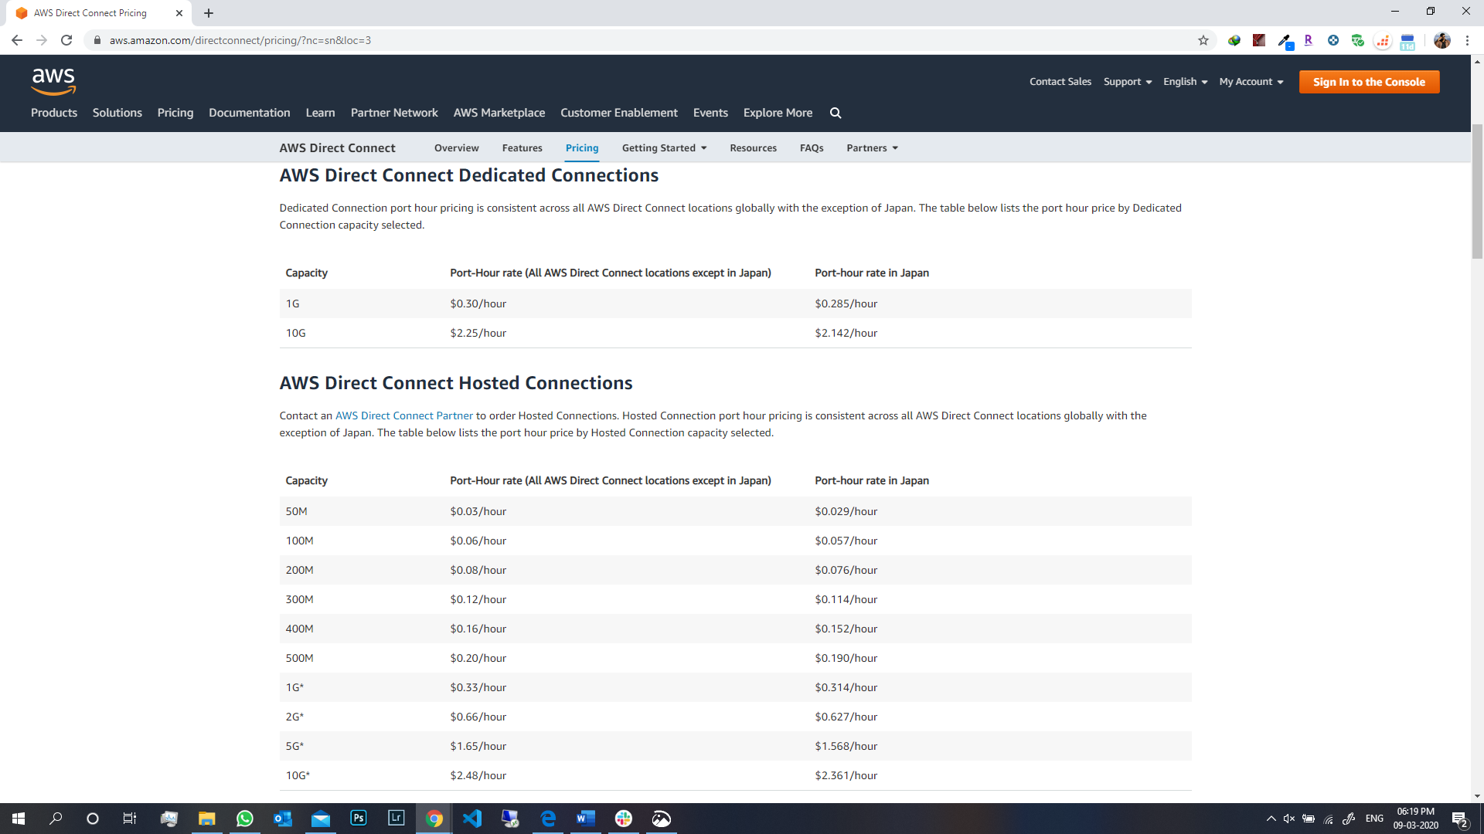

(Reference: <https://aws.amazon.com/directconnect/pricing/?nc=sn&loc=3> & <https://aws.amazon.com/directconnect/?nc=sn&loc=1> )

**b.** With AWS Direct Connect, you can establish 10 Gbps dedicated network connections between AWS Direct Connect locations and AWS. A dedicated connection can be partitioned into multiple logical connections by using industry-standard 802.1QVLANs.This connection can be used to access public resources such as objects stored in Amazon Simple Storage Service.

For example, you could attach a VPC to your existing data center with a virtual private gateway and set up an additional public subnet to connect to other AWS services that do not run within the VPC, such as Amazon S3, Amazon Simple Queue Service (Amazon SQS) or Amazon Simple Notification Service (Amazon SNS).

VPN connections have low to modest bandwidth requirements and can tolerate variability in internet-based connectivity.AWS direct connect uses dedicated, private network connections between intranet and Amazon VPC.

AWS will locate private IPs in the 169.x.x.x range for the BGP session and will advertise the VPC CIDR block over BGP.

(Reference: <https://docs.aws.amazon.com/directconnect/latest/UserGuide/dc-ug.pdf> & <https://aws.amazon.com/directconnect/faqs/> )

**3. (10 points) Describe how the AWS Direct Connect service can be used with the Amazon Virtual Private Cloud (VPC).**

**Ans:** AWS Direct Connect links the internal network to an AWS Direct Connect location over a standard 1 gigabit or 10 gigabit Ethernet fiber-optic cable. One end of the cable is connected to your router, the other to an AWS Direct Connect router.

We can create virtual interfaces directly to the AWS cloud and Amazon VPC, bypassing Internet service providers in your network path. When you create a private virtual interface to a VPC you want to connect. This connection requires the use of the Border Gateway Protocol.

Details to get connection:

• A public or private ASN.If a user is using public ASN then he has to own it, if he is using ASN,then it must be in the 65000 range.

• A new unused VLAN tag that you select.

• The VPC Virtual Private Gateway id

The Virtual Private Gateway to connect:

• Verify that the VLAN is not already in use on this connection.

• Open the AWS Direct Connect console.

• In the connection pane, select the connection to use, and then click Create Virtual Interface.

• In the Create a Virtual Interface pane, select Private.

• Under Define Your New Private Virtual Interface

• Enter a name for the virtual interface in the Interface Name field.

• In the Interface Owner, select the My AWS Account option if the virtual interface is for your AWS account ID.

• Select the virtual gateway to connect to, In the VGW list.

• In the VLAN # field, enter the ID number for your virtual local area network (VLAN) for example, a number between 1 and 4094.

• To have AWS generate your router IP address and Amazon IP address, select Auto-generate peer IPs.

• To specify these IP addresses yourself, clear the Auto-Generated peer IPs checkbox, and then in the Your router peers IP field, enter the destination IPv4 CIDR address that Amazon should send traffic to. In the Amazon router peer IP field, enter the IPv4 CIDR address you will use to Amazon Web Services.

• In the BGP ASN filed, enter the Border Gateway Protocol (BGP) Autonomous System Number (ASN) of your gateway; for example, a number between 1 and 65534.

• Select Auto-generate BGP key checkbox to have AWS generate one.

To provide your BGP key, clear the Auto-generate BGP key check box and then in the BGP Authorization key field, enter your BGP MD5 key.

Download your router configuration and configure the router.

AWS Direct Connect Interfaces with the network.

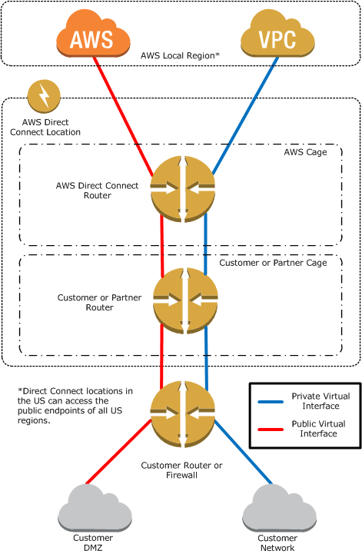

(References: <https://datacenterrookie.wordpress.com/2017/03/03/direct-connect-to-the-aws-cloud/> , [https://aws.amazon.com/directconnect/](https://aws.amazon.com/directconnect/%20) , <https://docs.aws.amazon.com/directconnect/latest/UserGuide> & <http://docs.aws.amazon.com/directconnect/latest/UserGuide/images/direct_connect_architecture.png> )

**4. (10 points) Note that Amazon VPC provides NAT.**

**a. Explain why you would want to use NAT for a virtual private subnet with the Amazon Direct Connect service. Do you see any cases where you would not want to use it?**

**b. What is the maximum number of connections a single NAT box can maintain? (You need to check the specifications of the three existing transport-layer protocols on the Internet: TCP, UDP, and SCTP, and also keep in mind that the first 4,096 ports have been reserved.)**

**Ans: Network address translation** (**NAT**) is a method of remapping one IP address space into another by modifying network address information in the IP header of packets while they are in transit across a traffic routing device. The technique was originally used as a shortcut to avoid the need to readdress every host when a network was moved. It has become a popular and essential tool in conserving global address space in the face of IPv4 address exhaustion. One Internet-routable IP address of a NAT gateway can be used for an entire private network.